* Create a snapshot  
    
  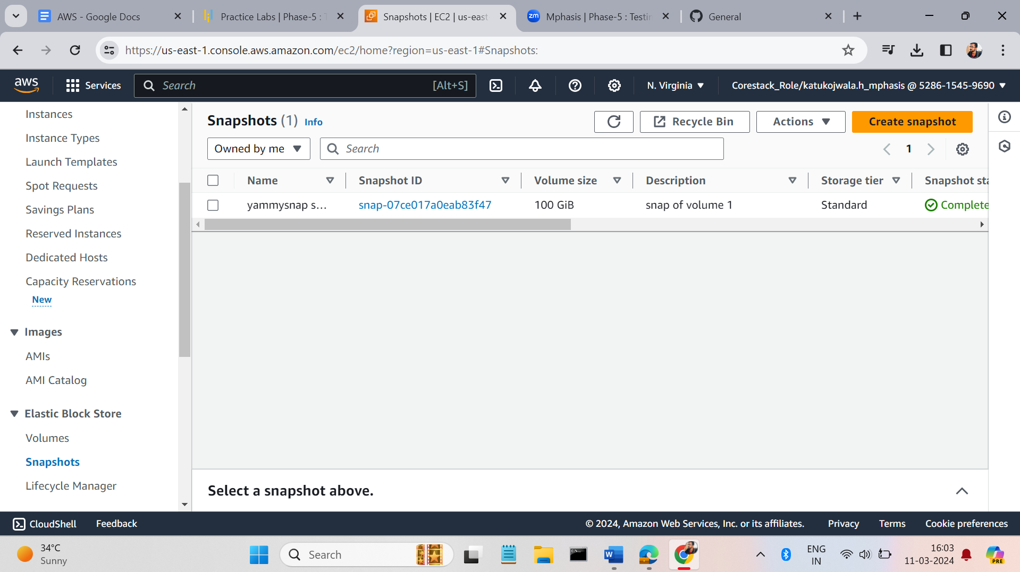
* On the right-hand size we a button like action click on that from the drop down menu we have a option like create a volume from the snapshot click on that.  
    
  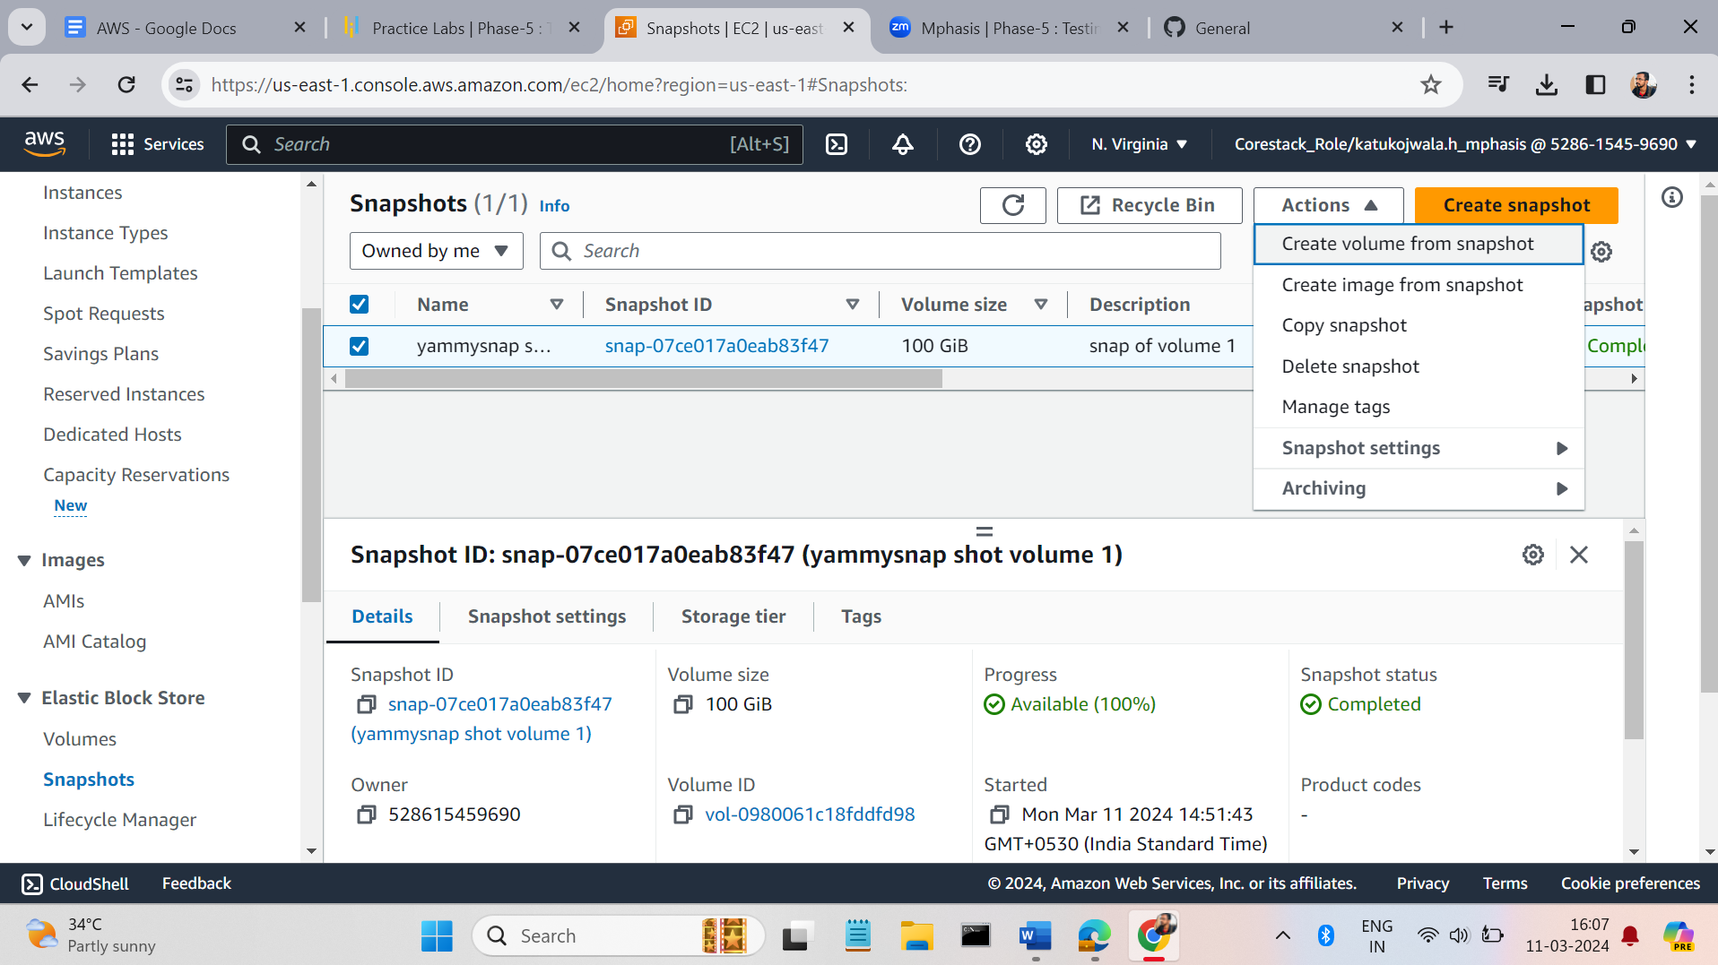
* Enter the details of volume  
    
  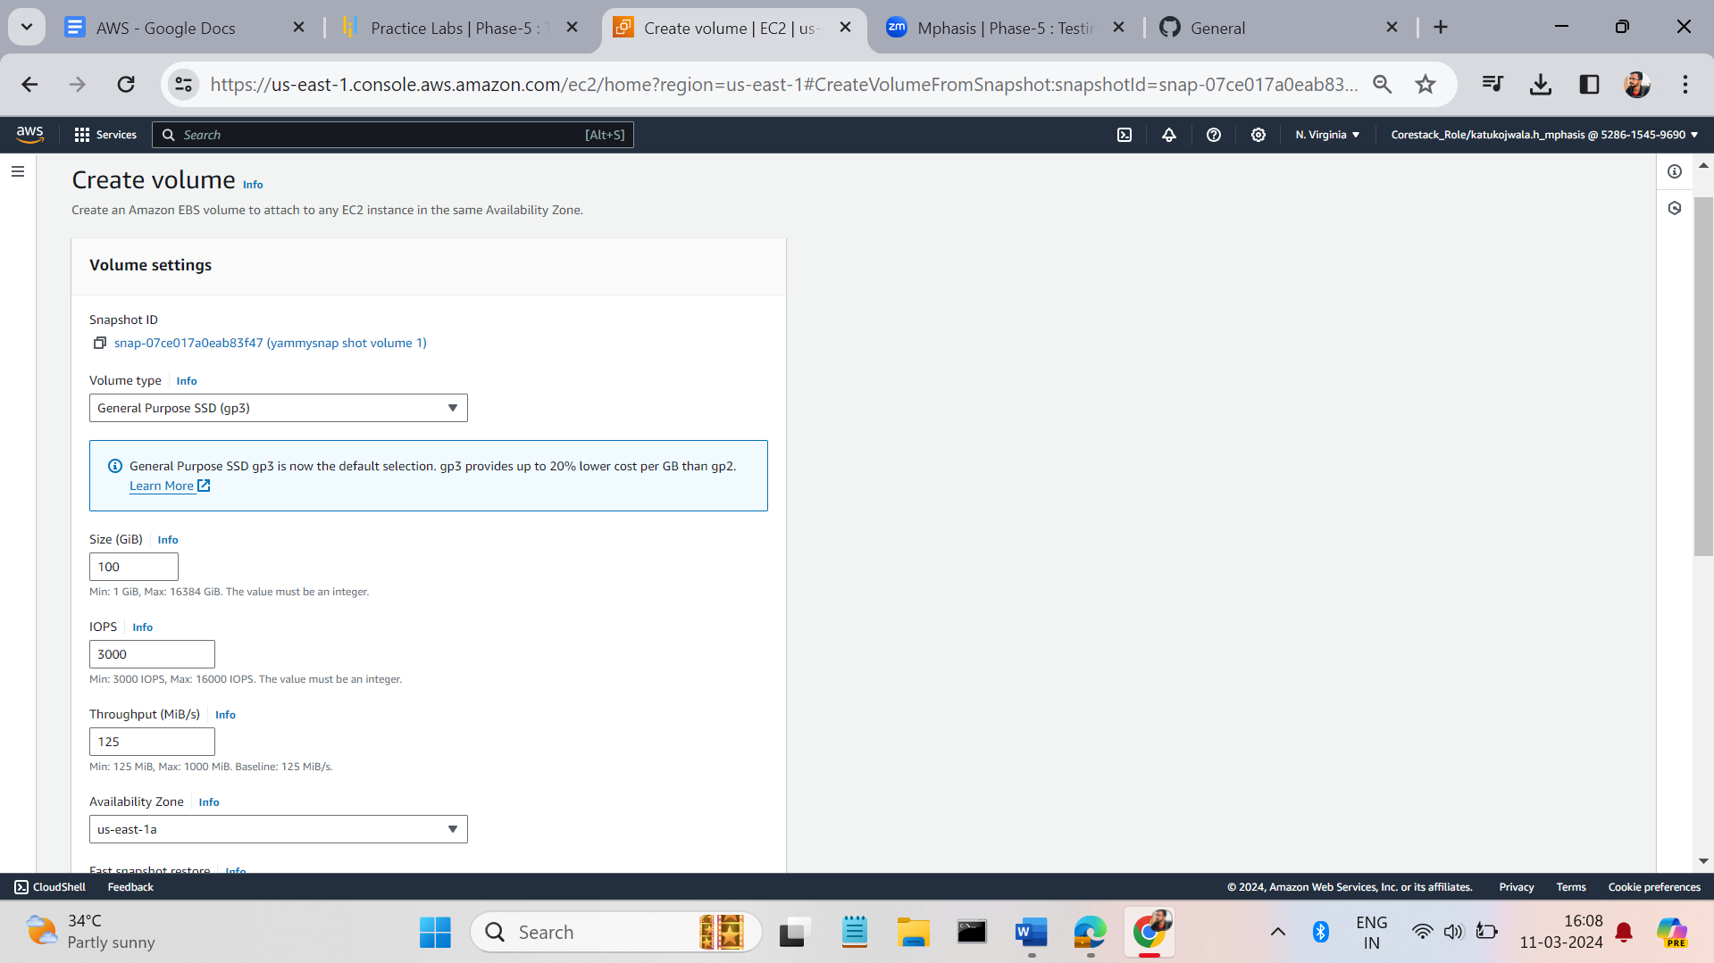
* A volume will created  
    
  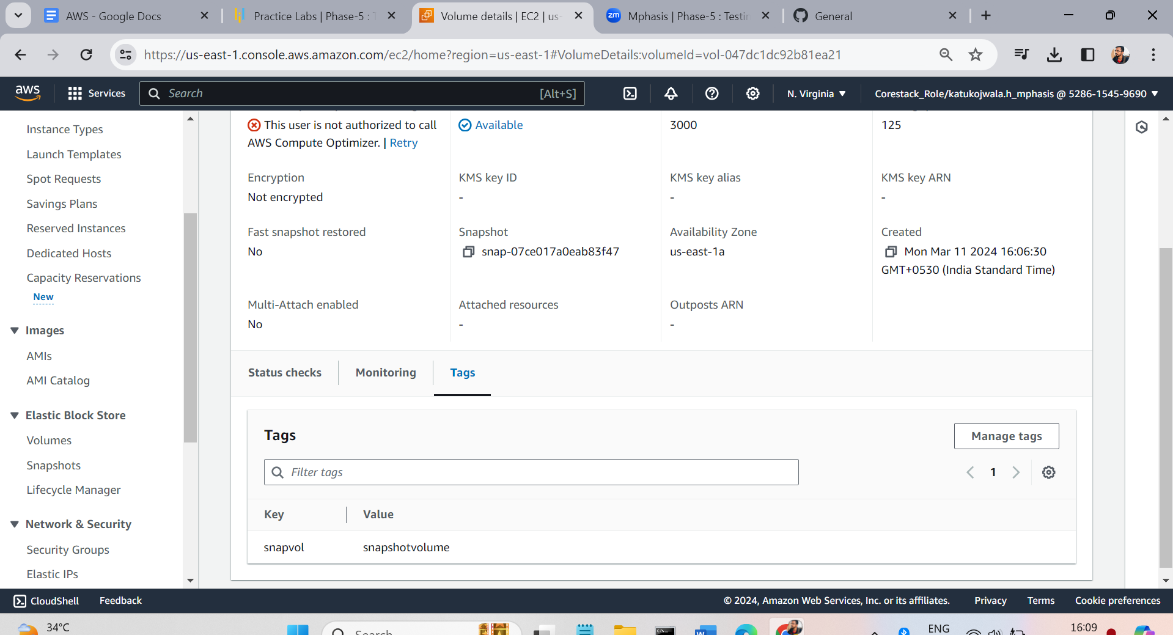
* Attach the volume to the instance. By view the option attach volume after the connect the instance.

